**CHAPTER 4**

**NORMALISATION**

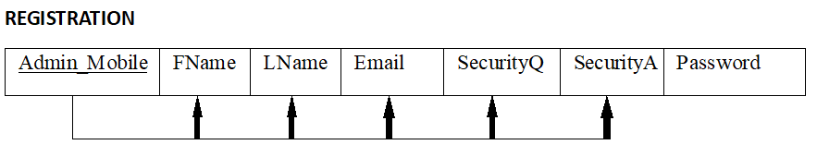

1NF: The relations are in 1NF since there are no multivalued attributes or nested relations.

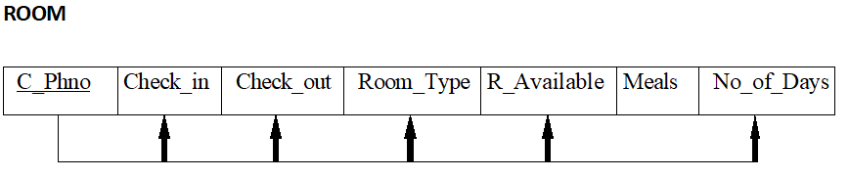

1NF: The relations are in 1NF since there are no multivalued attributes or nested relations.

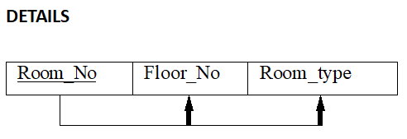

1NF: The relations are in 1NF since there are no multivalued attributes or nested relations.

**CUSTOMER**

|  |  |  |  |  |  |  |  |  |  |
| --- | --- | --- | --- | --- | --- | --- | --- | --- | --- |
| C_Mobile | C_Ref | CName | FName | Gender | C_Email | Nationality | C_IdType | C_IdProof | Address |

1NF: The relations contains multivalued attributes, hence it is not in 1NF.

To normalize it, we create two tables.

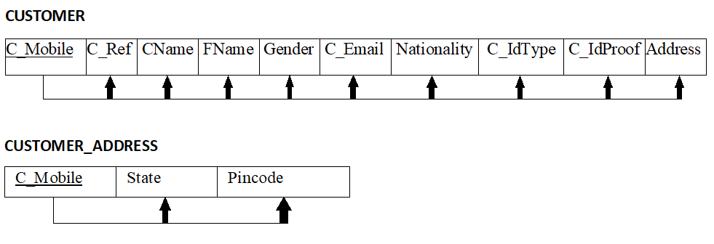

Now, the relation is in 1NF.

**STAFF**

|  |  |  |  |  |  |  |  |  |  |
| --- | --- | --- | --- | --- | --- | --- | --- | --- | --- |
| StaffID | S_Mobile | SName | Doj | Gender | C_Email | Occupation | C_IdType | C_IdProof | Address |

1NF: The relations contains multivalued attributes, hence it is not in 1NF.

To normalise it we create two tables.

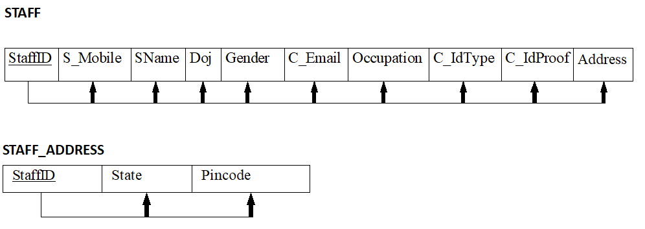

Now, the relation is in 1NF.